WEEK - 8
Yash Raj
SuperSet ID - (6364442)

2.Git-HOL
Installing Git
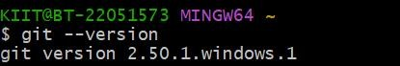
Configuring the username and user-email
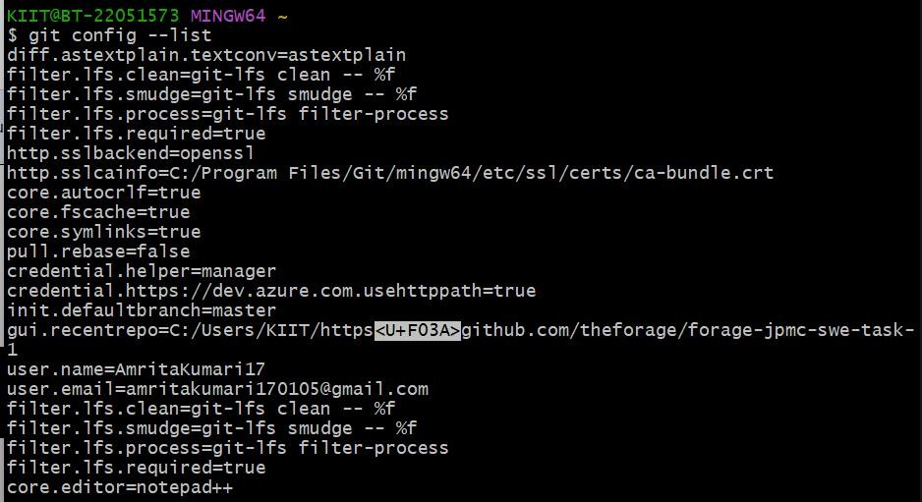
Making new folder and initializing git
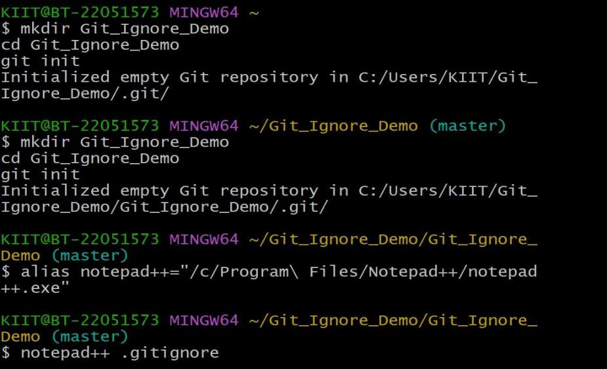

Creating and checking the file
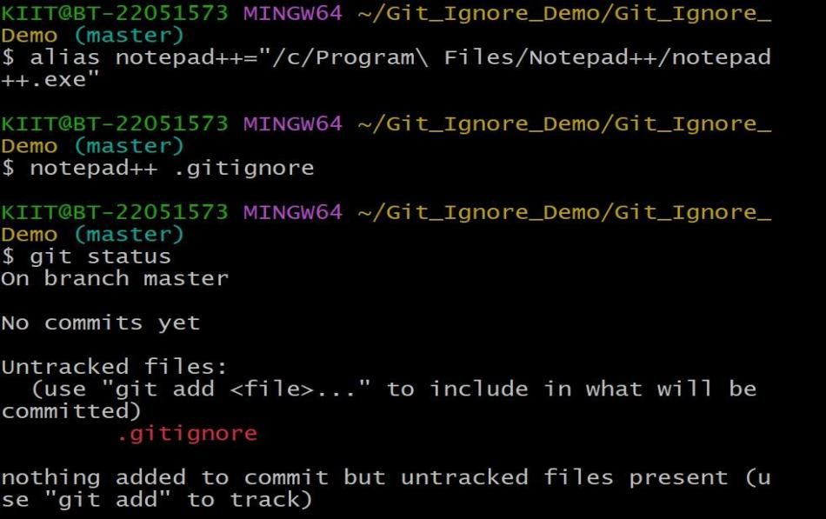
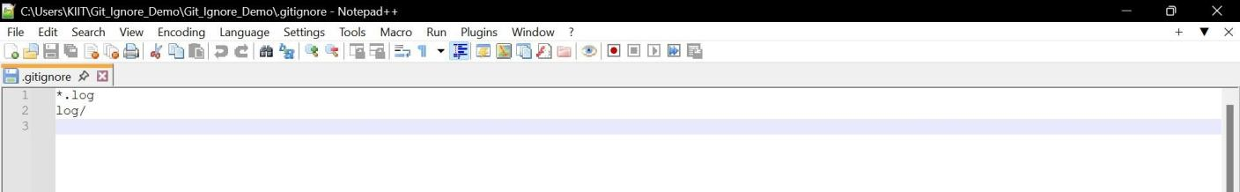

Adding file to git and commit
